South Africa

## GNI per capita and development level

The data set shows the GNI per capita and development level of the country each year.

## # A tibble: 19 x 5  
## country iso3c date GNIperCapita devCategory   
## <chr> <chr> <dbl> <dbl> <chr>   
## 1 South Africa ZAF 1996 5635. Upper Middle Income  
## 2 South Africa ZAF 1998 5609. Upper Middle Income  
## 3 South Africa ZAF 2000 5811. Upper Middle Income  
## 4 South Africa ZAF 2002 6021. Upper Middle Income  
## 5 South Africa ZAF 2003 6109. Upper Middle Income  
## 6 South Africa ZAF 2004 6356. Upper Middle Income  
## 7 South Africa ZAF 2005 6607. Upper Middle Income  
## 8 South Africa ZAF 2006 6888. Upper Middle Income  
## 9 South Africa ZAF 2007 7063. Upper Middle Income  
## 10 South Africa ZAF 2008 7205. Upper Middle Income  
## 11 South Africa ZAF 2009 7057. Upper Middle Income  
## 12 South Africa ZAF 2010 7172. Upper Middle Income  
## 13 South Africa ZAF 2011 7261. Upper Middle Income  
## 14 South Africa ZAF 2012 7295. Upper Middle Income  
## 15 South Africa ZAF 2013 7365. Upper Middle Income  
## 16 South Africa ZAF 2014 7381. Upper Middle Income  
## 17 South Africa ZAF 2015 7368. Upper Middle Income  
## 18 South Africa ZAF 2016 7267. Upper Middle Income  
## 19 South Africa ZAF 2017 7247. Upper Middle Income

## GDP growth and economic growth classification

The data set shows the GDP growth and the ecomic growth classification of the country each year.

## # A tibble: 19 x 5  
## country iso3c date GDPannualGrowthRate GDPgrowthCategory4  
## <chr> <chr> <dbl> <dbl> <fct>   
## 1 South Africa ZAF 1996 4.30 moderate growth   
## 2 South Africa ZAF 1998 0.500 slow growth   
## 3 South Africa ZAF 2000 4.20 moderate growth   
## 4 South Africa ZAF 2002 3.70 moderate growth   
## 5 South Africa ZAF 2003 2.95 moderate growth   
## 6 South Africa ZAF 2004 4.55 moderate growth   
## 7 South Africa ZAF 2005 5.28 moderate growth   
## 8 South Africa ZAF 2006 5.60 fast growth   
## 9 South Africa ZAF 2007 5.36 moderate growth   
## 10 South Africa ZAF 2008 3.19 moderate growth   
## 11 South Africa ZAF 2009 -1.54 negative grwoth   
## 12 South Africa ZAF 2010 3.04 moderate growth   
## 13 South Africa ZAF 2011 3.28 moderate growth   
## 14 South Africa ZAF 2012 2.21 slow growth   
## 15 South Africa ZAF 2013 2.49 slow growth   
## 16 South Africa ZAF 2014 1.85 slow growth   
## 17 South Africa ZAF 2015 1.19 slow growth   
## 18 South Africa ZAF 2016 0.399 slow growth   
## 19 South Africa ZAF 2017 1.41 slow growth

## Development trend

The plot shows the development trend of the country.

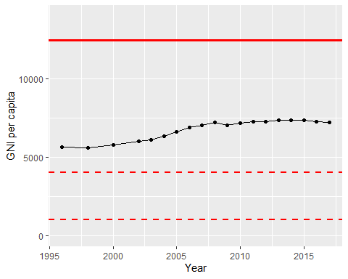

GNI Per Capita Trend